4. Implementation of semester registration form.

<!DOCTYPE html>

<html lang="en">

  <head>

    <meta charset="UTF-8" />

    <meta name="viewport" content="width=device-width, initial-scale=1.0" />

    <title>Semester Registration Form</title>

    <style>

      .container {

        width: 300px;

        border: 15px solid lightseagreen;

        margin: 20px;

        padding: 50px;

        align-items: safe;

        padding-left: 100px;

        background-color: wheat;

      }

      .submit {

        background-color: red;

        border-radius: 4px;

        height: 25px;

        color: whitesmoke;

        cursor: pointer;

        border: 1px solid red;

        margin: 0 0 0 100px;

      }

    </style>

  </head>

  <body>

    <caption>

      Registration Form

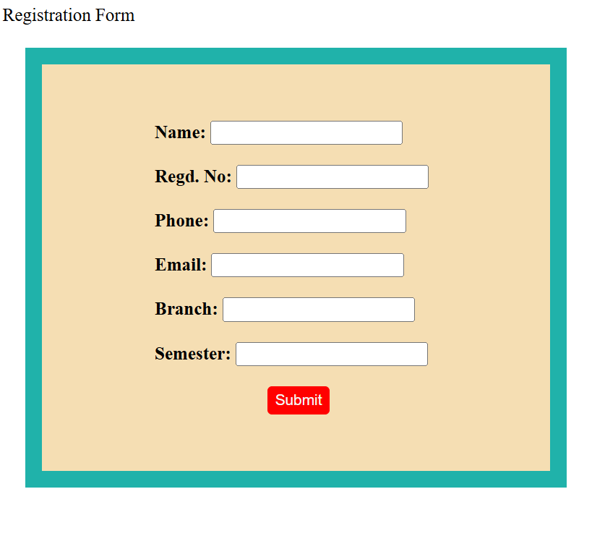    </caption>

    <form action="" class="container">

      <label for="name"><strong>Name: </strong></label>

      <input type="text" />

      <br /> <br />

      <label for="name"><strong>Regd. No: </strong></label>

      <input type="number" />

      <br /> <br />

      <label for="number"><strong>Phone: </strong></label>

      <input type="number" />

      <br /> <br />

      <label for="mail"><strong>Email: </strong></label>

      <input type="email" />

      <br /> <br />

      <label for="name"><strong>Branch: </strong></label>

      <input type="text" />

      <br /> <br />

      <label for="name"><strong>Semester: </strong></label>

      <input type="number" />

      <br /> <br />

      <input class="submit" type="submit" />

    </form>

  </body>

</html>